Brandon Simpson   
Csc 460  
December 3 2019  
How To Guide

The Blackjack game is created for the user to experiment the reality of an actual Blackjack game with a dealer and a player. When the user first opens the application, the dealer will already have his one card and you will start off with your first two cards, with the starting bet being “1”.

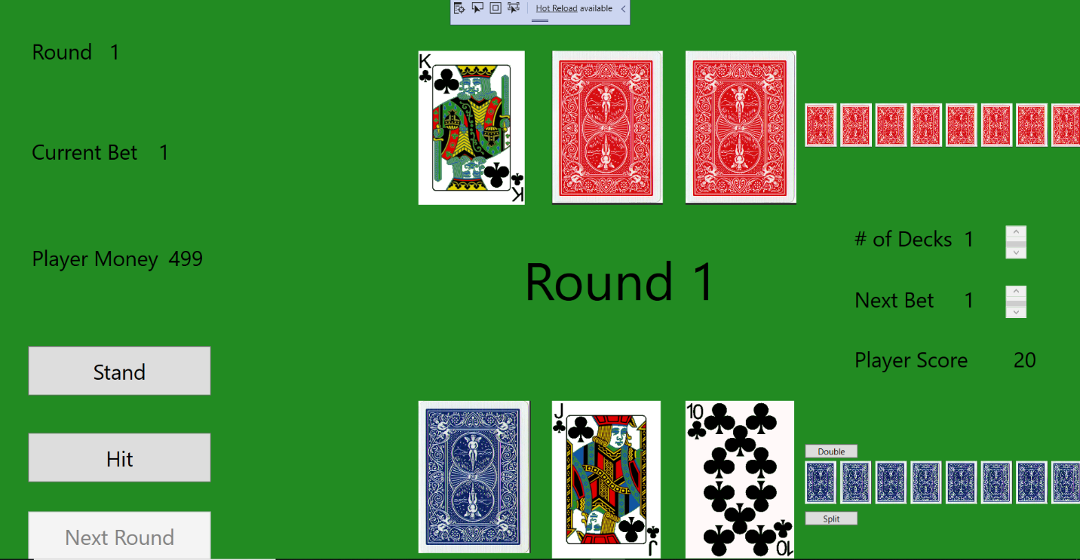You will begin by deciding whether you will want to hit or stand by clicking the hit or stand button. If you decided to hit, the application will continue to allow you to hit until you are at or over 21. This will change the middle label to “You win” or “You lose”. If you decide to stand the game will stop allowing you to push the hit and the stand button and the application will automatically dispense the dealers cards until he is at 17 or at or above 21. You will then be set to begin the next round. 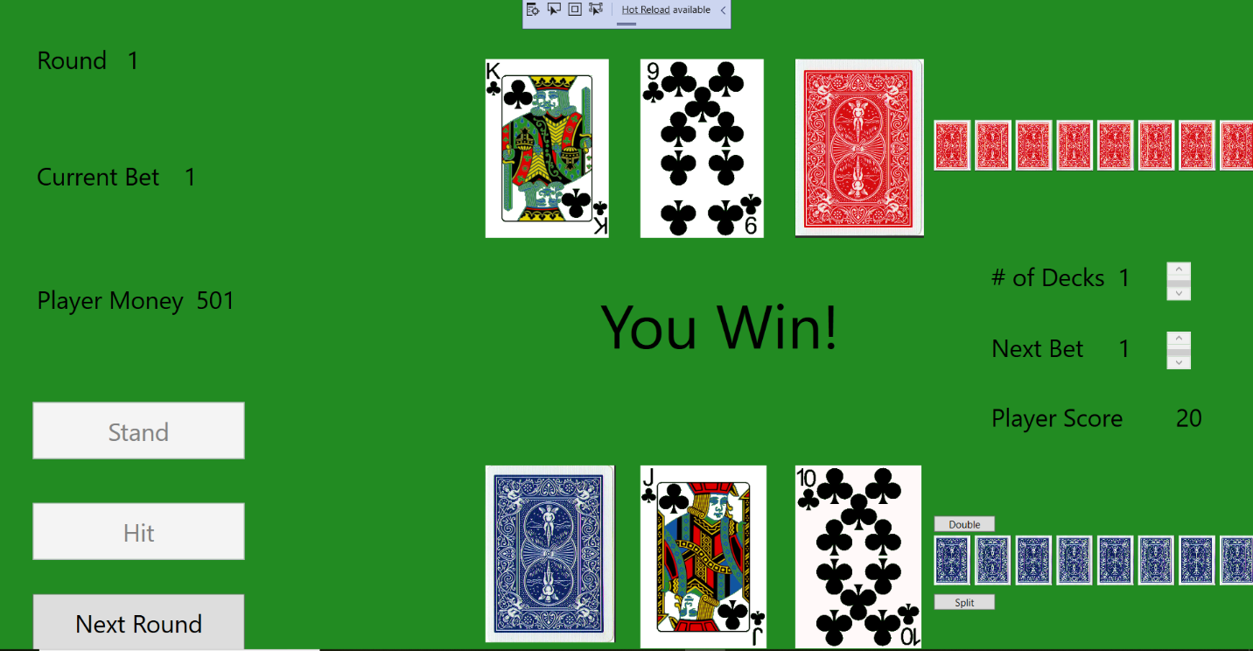

You will then able to change the amount of decks you can use and the amount of money you are willing to bet. You will start at 500 dollars to bet in the entire game. After you click the next round button you will begin the next round just as you started the beginning of the game where you are prompt to choose hit or stand button to countinue to the next sequence.

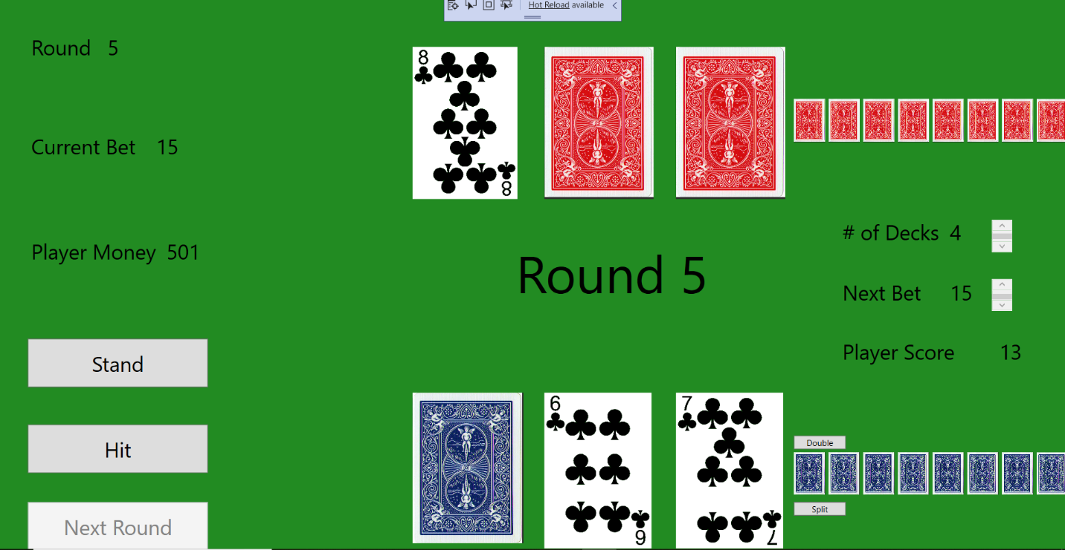

You can also be prompted with an automatic Blackjack from either the dealer or the player at the beginning of each round that will result in an automatic win. The game will continue until you run out of cards in the deck and you can then exit the application. Thanks for reading my How -To-Guide.